

Cloud Brain

Functional Specification Document

August 13, 2018

Rahul Maindalkar

Email: rahul.maindalkar@click2cloud.net

Document Version – V 1.0

Version History

|  |  |  |  |
| --- | --- | --- | --- |
| Version | Date | Name | Description of Change |
| 1.0 | 08/13/2018 | Rahul Maindalkar | Initial Document Creation |
|  |  |  |  |
|  |  |  |  |
|  |  |  |  |
|  |  |  |  |

Reviewers

|  |  |  |  |
| --- | --- | --- | --- |
| Name | Version Approved | Role | Date |
| Sarang Ghawde | 1.0 | PM |  |
|  |  |  |  |
|  |  |  |  |
|  |  |  |  |
|  |  |  |  |

Table of Contents

Introduction 3

Objectives 3

Scope 3

Assumptions and Constraints 3

Assumptions 3

Constraints 3

References 4

Architecture Overview 4

Component Structure 4

Software 4

Disclaimer 5

Appendix A: Glossary 5

Appendix B: Document Change History and Sign-off 5

Point of Contact 5

# Introduction

## Objectives

The objective of this document is to describe technical and functional specification on Cloud Brain. This document covers scope of Cloud Brain and detailed on different functionalities which will provide by Cloud Brain. The Cloud Brain will coverers the implementation of Cloud Intel, Cloud Compare, Cloud Monitoring, Optimizer, Migration and Devops Studio.

The adoption of cloud computing has quickly become a key driving force for businesses today, as applications are moved out of on-premise data centers in a bid to cut costs and increase agility. Selecting one cloud over the others will come down to the wants and needs of each individual customer and the workloads they are running. However, there are many differentiating features that separate the approaches of the cloud provides, which can help end-users consider which is right for them. So, Cloud Brain is a tool that enables you to easily compare cloud providers of leading clouds based on the features they offer to take right decision, helps user to monitor cloud cost and consumption of multiple cloud accounts and help user in optimizing cloud by giving recommendation depends on their consumption and provides the facility of migration.

## Scope

As a part of project scope for first phase, we would develop Cloud Brain with following functionalities

1. Cloud Intel
2. Monitoring
3. Optimizer
4. Compare

Other tasks than above task, for first phase, are not in the scope of project.

## Assumptions and Constraints

### Assumptions

1. We assume that, the data which we required to implement new functionalities (Cloud Intel, Optimizer) are already available in Manageiq’s PostgreSQL database.
2. We assume that, the usage data (Usage and Billing) of Clouds which are supported by Manageiq are already present in Manageiq’s PostgreSQL database in the form of Chargeback table.
3. We assume that, we don’t need to find API/SDK of Cloud Provider which are supported by ManageIq as the data of that Cloud Providers are already present in Manageiq’s PostgreSQL database.
4. Change in any functional requirement documented below shall be treated as CR (Change Request).
5. This document to be freeze and sign-off before implementation start.

### Constraints

1. During development phase if we found that the data which we required to implement any functionality is not present in Manageiq’s PostgreSQL database, then it may take some extra efforts in implementing that functionality.

## References

* https://github.com/ManageIQ/

## 

## Architecture Overview

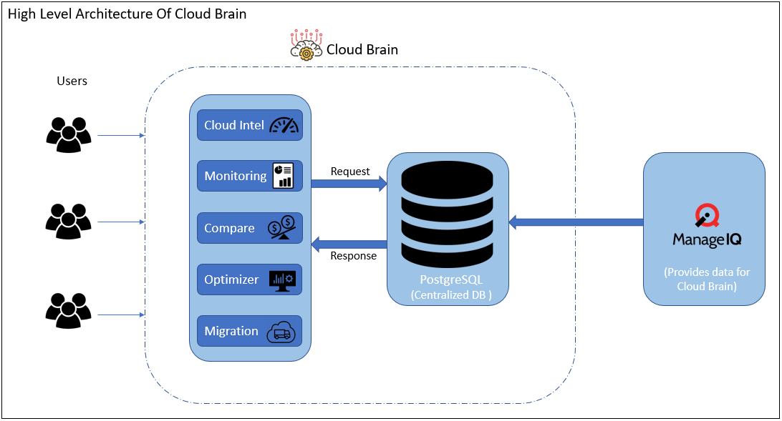

## Component Structure

As the image above:

1. ManageIQ is an open source management platform for Hybrid IT. It can manage small and large environments, and supports multiple technologies such as virtual machines, public clouds and containers.
2. ManageIQ will provide data for the Cloud Brain.

## 

## Software

* React.js
* Node.js
* PostgreSQL

# Disclaimer

This **DRAFT** Specification is being forwarded to you strictly for informational purposes and sign-off requirement before development starts. The specification is "AS IS," "WITH ALL FAULTS" and Click2Cloud makes no warranties, and disclaims all warranties, express, implied, or statutory related to the specifications. THE CORPORATIONS ARE NOT LIABLE FOR ANY INCOMPLETENESS OR INACCURACIES. THE CORPORATIONS ARE NOT LIABLE FOR ANY CONSEQUENTIAL, INCIDENTAL, OR INDIRECT DAMAGES RELATING TO THE SPECIFICATIONS OR THEIR USE.

# Appendix A: Glossary

|  |  |  |
| --- | --- | --- |
| No. | Initial Name | Description |
| 1 | CR | Change Request |
| 2 | FSD | Functional Specification Document |

# Appendix B: Document Change History and Sign-off

|  |  |  |  |
| --- | --- | --- | --- |
| Version No. | Date | Name | Sign-Off by |
|  |  |  |  |
|  |  |  |  |
|  |  |  |  |
|  |  |  |  |

# Point of Contact

|  |  |  |
| --- | --- | --- |
| Name | Designation | Email |
| Sarang Ghawde | Project Manager | sarang.ghawde@click2cloud.net |
| Rahul Maindalkar | Software Design Engineer - I | rahul.maindalkar@click2cloud.net |